**URBAN CLAP**

Expert Services, Anytime, Anywhere

**L .J. SCHOOL OF COMPUTER APPLICATION**



Developed By:

Muhammed Jawwad Shaikh (22004501210061)

Faiz Saiyed (22004501210056)

Muhammed Pehlari (22004501210048)

Tariq Shaikh (22004501210058)

Guided By:

Prof. Parthvi Soni

Group no: Imca_6_a_g1

**L .J. SCHOOL OF COMPUTER APPLICATION**

**LJ Campus, LJ University Road, Off S.G. Road, Ahmedabad-382210**



***CERTIFICATE***

**Enrollment No:22004501210061**

**This is to certify that Mr. Muhammed Jawwad Shaikh, of Integrated Master of Computer Applications, Semester 6 during the academic year 2024-2025 has satisfactorily completed his project titled “Urban Clap” .**

**Internal Guide Name Head of Department**

**Prof. Pratvi Soni Dr. Monica Gahalawat**

**Signature:**

**Date of Submission: 21/04/2025**

**Director**

**Prof. Alok Manke**

**L.J. SCHOOL OF COMPUTER APPLICATION**

**L .J. SCHOOL OF COMPUTER APPLICATION**

**LJ Campus, LJ University Road, Off S.G. Road, Ahmedabad-382210**



***CERTIFICATE***

**Enrollment No:22004501210056**

**This is to certify that Mr. Faiz Saiyed, of Integrated Master of Computer Applications, Semester 6 during the academic year 2024-2025 has satisfactorily completed his project titled “Urban Clap” under the supervision of Prof. Pratvi Soni.**

**Internal Guide Name Head of Department**

**Prof. Pratvi Soni Dr. Monica Gahalawat**

**Signature:**

**Date of Submission: 21/04/2025**

**Director**

**Prof. Alok Manke**

**L.J. SCHOOL OF COMPUTER APPLICATION**

**L .J. SCHOOL OF COMPUTER APPLICATION**

**LJ Campus, LJ University Road, Off S.G. Road, Ahmedabad-382210**



***CERTIFICATE***

**Enrollment No:22004501210048**

**This is to certify that Mr. Muhammed Pehlari, of Integrated Master of Computer Applications, Semester 6 during the academic year 2024-2025 has satisfactorily completed his project titled “Urban Clap” under the supervision of Prof. Pratvi Soni.**

**Internal Guide Name Head of Department**

**Prof. Pratvi Soni Dr. Monica Gahalawat**

**Signature:**

**Date of Submission: 21/04/2025**

**Director**

**Prof. Alok Manke**

**L.J. SCHOOL OF COMPUTER APPLICATION**

**L .J. SCHOOL OF COMPUTER APPLICATION**

**LJ Campus, LJ University Road, Off S.G. Road, Ahmedabad-382210**



***CERTIFICATE***

**Enrollment No:22004501210058**

**This is to certify that Mr. Tariq Shaikh, of Integrated Master of Computer Applications, Semester 6 during the academic year 2024-2025 has satisfactorily completed his project titled “Urban Clap” under the supervision of Prof. Pratvi Soni.**

**Internal Guide Name Head of Department**

**Prof. Pratvi Soni Dr. Monica Gahalawat**

**Signature:**

**Date of Submission: 21/04/2025**

**Director**

**Prof. Alok Manke**

**L.J. SCHOOL OF COMPUTER APPLICATION**

Contents

**1.** **Introduction** 7

1.1. Existing System 7

1.2. Need for the New System 8

1.3. Objective of the New System 8

1.4. Problem Definition 10

1.5. Core Components 10

1.6. Project Profile 11

1.7. Assumptions and Constraints 12

1.8. Advantages and Limitations of the Proposed System 13

1.9. Proposed Time Line Chart 15

2. **Requirement Determination & Analysis** 15

2.1. Requirement Determination 15

2.2. Targeted Users 16

3. **System Design** 17

3.1. Use Case Diagram 17

3.2. Class Diagram 18

3.3. Interaction Diagram 19

3.4. Activity Diagram 22

3.5. Data Dictionary 25

4. **Development** 27

4.1. Coding Standards 28

4.2. Screenshots 29

5. **Agile Documentation** 35

5.1. Agile Project Charter 35

5.2. Agile Road Map 36

5.3. Agile Project Plan 36

5.4. Agile User Story ( Minimum 3 Tasks) 37

5.5. Agile Release Plan 37

5.6. Agile Sprint Backlog 38

5.7. Agile Test Plan 39

5.8. Earned-value and burn charts 40

6. **Proposed Enhancements** 41

7. **Conclusion** 41

8. **Bibliography** 42

# **Introduction**

## This document takes a closer look at the UrbanClap platform, exploring how it operates, the services it offers, and what makes its business model stand out. It shares the story behind UrbanClap’s success as a trusted name in the home services industry, highlighting the strategies and practices that have helped it thrive. The document also explains how UrbanClap brings service providers and customers together, creating a smooth and hassle-free experience for both. At its core, this document aims to show how UrbanClap is redefining traditional home services with the help of smart technology and a customer-first approach.

## **Existing System**

The existing system can be either manual or automated, depending on how advanced it is. Let’s assume it’s a mix of both for simplicity.

Key Processes in the System

1. Customer Registration
   * Customers sign up on the platform by providing details like name, email, phone number, and location.
   * This can be done manually (e.g., filling out a form) or automated (e.g., through a website or app).
2. Service Professional Registration
   * Service providers (like plumbers, electricians, etc.) register on the platform by providing their details, skills, and availability.
   * This can also be manual or automated.
3. Service Request by Customer
   * A customer selects a service they need (e.g., cleaning, plumbing) and provides details like location, date, and time.
   * The system matches the customer’s request with available service professionals.
4. Matching and Booking
   * The system automatically matches the customer’s request with the most suitable service professional based on location, availability, and skills.
   * In a manual system, an admin might do this matching process.
5. Payment Processing
   * Once the booking is confirmed, the customer makes a payment. This can be done online (automated) or offline (manual, like cash payment).
6. Service Execution
   * The service professional visits the customer’s location and completes the job.

Work Flow Diagram

Customer Registration → Service Request → Matching & Booking → Payment → Service Execution

## **Need for the New System**

**No Feedback System:**

* **Problem:** There’s no way for customers to rate or review service professionals.
* **Result:** It’s hard to know which professionals are reliable and which ones to avoid.
* **Example:** A customer might book a service and end up with a poorly skilled professional

**No Service History:**

* **Problem:** Customers can’t see their past bookings, and professionals can’t track their work history.
* **Result:** Customers can’t easily rebook a good professional, and professionals can’t analyse their performance.
* **Example:** A customer might forget the name of a great cleaner they hired last time.

**No Verification Process:**

* Problem: Anyone can sign up as a service professional without any checks.
* Result: Platform reputation may harm
* Example: A customer might end up with an unskilled or unreliable professional.

## **Objective of the New System**

* **Improve Trust and Safety Through Service Provider Verification**
* **Objective:** Implement a **verification process** for service providers to ensure only qualified and trustworthy professionals are on the platform.
* **How It Addresses Challenges:**
  + Solves the problem of unskilled or unreliable professionals.
  + Builds trust with customers by displaying a "Verified" badge on profiles.
* **Expected Outcome:**
  + Increased customer confidence in booking services.
  + Reduced fraud and scams on the platform.
  + Builds trust with customers by displaying a "Verified" badge on profiles.
* **Enhance Customer Experience with Feedback & Rating System**
* **Objective:** Introduce a **feedback and rating system** to allow customers to rate and review service providers after each job.
* **How It Addresses Challenges:**
  + Solves the problem of customers not knowing which professionals are reliable.
  + Helps service providers improve their performance based on feedback.
* **Expected Outcome:**
  + Improved service quality as professionals strive for higher ratings.
  + Better decision-making for customers when booking services.
* **Enable Easy Rebooking and Performance Tracking with Service History**
* **Objective:** Add a **service history feature** to track past bookings for customers and work history for service providers.
* **How It Addresses Challenges:**
  + Solves the problem of customers forgetting good professionals they’ve used before.
  + Allows service providers to track their performance and earnings.
* **Expected Outcome:**
  + Increased customer loyalty as they can easily rebook trusted professionals.
  + Service providers can analyze their work history to improve their skills and earnings.
* **Increase Transparency and Accountability**
* **Objective:** Make the platform more transparent by displaying **verified badges**, **ratings**, and **service history**.
* **How It Addresses Challenges:**
  + Solves the problem of customers not knowing if a professional is trustworthy.
  + Encourages service providers to maintain high standards to get better ratings.
* **Expected Outcome:**
  + Higher trust and engagement from customers.
* **Enhance Platform Reputation**
* **Objective:** Build a reputation for quality and reliability by ensuring only verified professionals are on the platform and by showcasing customer feedback.
* **How It Addresses Challenges:**
  + Solves the problem of poor service quality and lack of trust.
* **Expected Outcome:**
  + More customers and service providers will join the platform.
  + Positive word-of-mouth and referrals.
  + A more professional and reliable workforce.

## **Problem Definition**

**The existing system has the following key problems:**

1. **No Verification Process: Unverified service providers lead to trust issues and poor service quality.**
2. **No Feedback & Rating System: Customers cannot rate or review professionals, making it hard to identify reliable providers.**
3. **No Service History: Customers cannot track past bookings, and professionals cannot analyse their performance.**

## **Core Components**

**The proposed system is a service booking platform (similar to UrbanClap) that connects customers with service professionals (e.g., plumbers, electricians, cleaners, etc.). The system will focus on addressing the key challenges of the existing system by introducing service provider verification, feedback & ratings, and service history tracking.**

**Key Features of the Proposed System**

**Service Provider Verification:**

* **A process to verify the identity, skills, and credentials of service professionals.**
* **Display a "Verified" badge on verified profiles to build trust.**

**Feedback & Rating System:**

* **Allow customers to rate and review service professionals after each job.**
* **Display ratings and reviews on professional profiles to help customers make informed decisions.**

**Service History Tracking:**

* **Maintain a record of past bookings for customers and work history for service professionals.**
* **Enable customers to easily rebook trusted professionals and allow professionals to track their performance.**

**User-Friendly Interface:**

* **A simple and intuitive platform (website or app) for customers and service professionals to use.**
* **Easy navigation for booking services, viewing profiles, and accessing service history.**

**Secure Payment Gateway:**

* **Integrate multiple payment options (e.g., UPI, credit/debit cards, digital wallets) for seamless transactions.**

## **Project Profile**

**Project Title –** UrbanClap “Expert Services, Anytime, Anywhere”

**Service Booking and Management Platform**  
(A platform similar to UrbanClap for connecting customers with verified service professionals.)

**Project Developer** : Tariq Shaikh - A28

Muhammed Pehlari - A46

Faiz Saiyed - A55

Jawwad Shaikh - A60

**Hardware Requirement** : Pentium 4 Micro Processor or Above

RAM 1 GB or Above

Hard Disk 60 GB or Above

**Software Requirement** : Platform : Window XP or Above

Front End : html, css Back End : Python

Framework : Django, Tailwind

Other Tools : MS Word (Documentation),

DeepSeek.Ai

Material Tailwind,

Flow Bite

## **Assumptions and Constraints**

* **Assumptions:**
* Internet Connectivity:
  + The system considers that customers and service providers are to have steady internet connectivity so that they will be able to access the portal, book their services, and receive real-time updates.
* Availability of Service Providers:
  + It is assumed that there would be enough service providers to meet the increased demand for services in various cities without lowering quality or response times.
* Customer Familiarity with Digital Platforms:
  + It is assumed that most of the customers would be aware of using mobile applications or web-based platforms for service booking. Hence, the user interface becomes important for seamless interactions.
* Customer Feedback Participation:
  + The system presumes that customers will actively provide feedback on services, which will be used by UrbanClap for continuous improvement and quality monitoring.
* Payment Gateway Integration:
  + The system assumes that all payment gateways and transaction processing systems will remain functional and secure to ensure smooth online payments for services rendered.
* Data Privacy and Security:
  + This project presumes that the customer and service provider data are safe and will adhere to the appropriate privacy laws, such as GDPR. Personal information and payment details will be safely stored
* Infrastructure Scalability:
  + The system assumes that the current IT infrastructure will scale with the growth of the user base and service provider pool without any major hardware or software upgrades.
* Compliance with Legal Regulations:
  + The project assumes that all legal requirements related to providing services (labor laws, health and safety, etc.) will be met by service providers and the platform.
* **Constraints:**
* Time Constraints:
  + The new system should be developed and deployed within a specific timeline of 6–9 months, which may restrict the scope of some advanced features, especially if some unexpected issues arise during implementation.
* Dependence on Third-Party Services:
  + The performance of the system will be dependent upon services that are under third parties, such as a payment gateway and notification services, like SMS and email which may face involuntary outages or a change in service terms or periods and rules.
* Platform Compatibility:
  + Ensuring the system works seamlessly across different devices (mobile, desktop) and operating systems (iOS, Android, Windows).

## **Advantages and Limitations of the Proposed System**

* **Advantages of the Proposed System:**
  + Verification Process: Introduces a **verification process** for service providers.
  + Feedback & Rating System: Adds a feedback and rating system.
  + Service History: Introduces a service history feature.
  + Enhances Transparency and Accountability: Displays verified badges,

ratings, and service history.

* + Boosts Platform Reputation: Builds a reputation for quality and reliability.
* **Limitations of the Proposed System**

Dependency on Internet Connectivity: The system requires **internet connectivity** to function.

* + **Scenario:**
  + In areas with poor or no internet access, customers and professionals won’t be able to use the platform.
  + Example: Rural areas or places with frequent network outages.

#### **Limited Adoption by Non-Tech-Savvy Users:** Some users (especially service professionals) might not be comfortable using a digital platform.

* + **Scenario:**
  + Professionals might struggle to upload documents for verification or use the app to accept bookings.
  + Example: Older professionals or those unfamiliar with smartphones.

#### **Scalability Issues:** The system might struggle to handle a large number of users or transactions as it grows.

* **Scenario:**
  + Increased traffic could slow down the platform or cause crashes.
  + Example: During peak booking times or promotional campaigns.

#### **Dependency on Third-Party Services:** The system relies on external services like payment gateways, GPS tracking, and cloud hosting.

* **Scenario:**
  + If a third-party service goes down, it could disrupt the platform’s functionality.
  + Example: Payment gateway failure during a transaction.

## **Proposed Time Line Chart**

|  |  |  |  |  |  |  |  |  |  |  |  |  |  |
| --- | --- | --- | --- | --- | --- | --- | --- | --- | --- | --- | --- | --- | --- |
| Month | January | | | | February | | | | March | | | | April |
| Weeks | 1 | 2 | 3 | 4 | 1 | 2 | 3 | 4 | 1 | 2 | 3 | 4 | 22 |
| Planning |  |  |  |  |  |  |  |  |  |  |  |  |  |
|  |  |  |  |  |  |  |  |  |  |  |  |  |  |
| Analysis |  |  |  |  |  |  |  |  |  |  |  |  |  |
|  |  |  |  |  |  |  |  |  |  |  |  |  |  |
| Design |  |  |  |  |  |  |  |  |  |  |  |  |  |
|  |  |  |  |  |  |  |  |  |  |  |  |  |  |
| Coding |  |  |  |  |  |  |  |  |  |  |  |  |  |
|  |  |  |  |  |  |  |  |  |  |  |  |  |  |
| Testing |  |  |  |  |  |  |  |  |  |  |  |  |  |
| Implementation |  |  |  |  |  |  |  |  |  |  |  |  |  |
| Documentation |  |  |  |  |  |  |  |  |  |  |  |  |  |

# **Requirement Determination & Analysis**

## **Requirement Determination**

* **Service Provider Input:**

Discussion with service providers in focused groups identified the problems: mismatches between demand and availability of services and inefficiencies in managing appointments. Their input would be on the need for a better scheduling and provider management system that would reduce manual effort and improve customer-provider interaction.

* **Customer Feedback:**

Surveys and feedback forms from existing customers were very informative. The common issues that emerged from the feedback included problems in booking services, lack of real-time updates, and unsatisfactory payment processes. Understanding the user's needs was crucial to shaping the design of the new system.

* **Analysis of Current System:**

A thorough review of the existing system revealed where and how improvements were needed. Observing existing workflows led us to pinpoint which steps could be automated, like booking, service provider matching, and payment processing.

## **Targeted Users**

* **Customers:**

**Role:** Customers are the main users of the platform who order services like beauty treatments, home repair, cleaning, etc. Their role includes browsing available services, booking appointments, making payments, and providing feedback on the quality of services received.

* **Service Providers (Professionals):**

**Role:** Service providers are the people providing the home services. Their responsibilities involve handling bookings, providing services according to the customers' needs, updating their availability, receiving payments, and ensuring service quality.

* **Customer Support Team:**

**Role:** The customer support team will assist customers in all issues relating to bookings, payments, service quality, or technical difficulties. They ensure that communication between the customers and the service providers runs smoothly and assist in solving service-related issues.

* **Admin/Backend Users:**

**Role:** Admin users manage all the aspects related to the complete platform, managing bookings, including service provider sign-up, taking care of all payment processes, customer support handling, and checking system analytics, and also ensures quality services as they monitor customer feedback.

# System Design

## Use Case Diagram

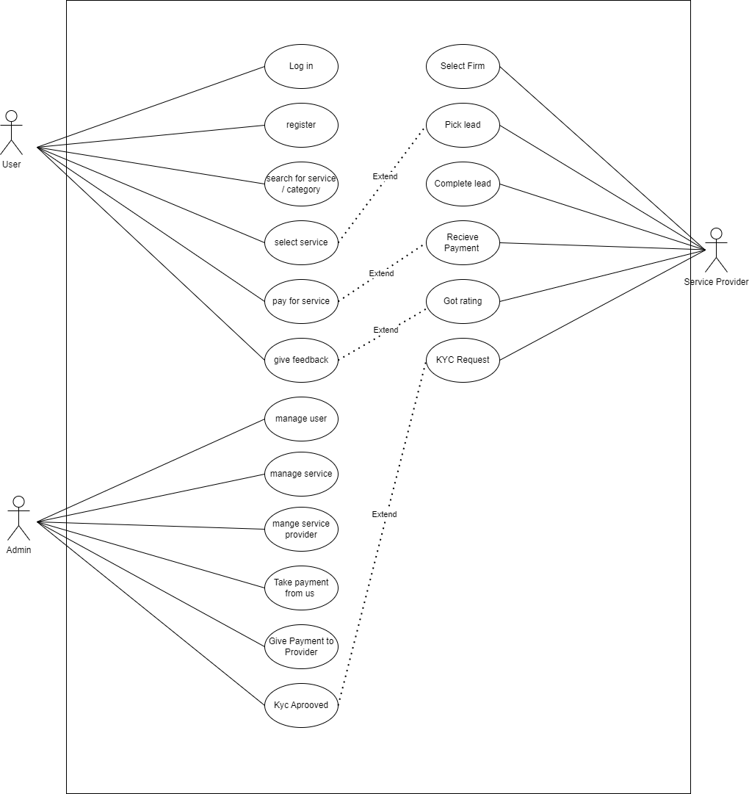

## Class Diagram

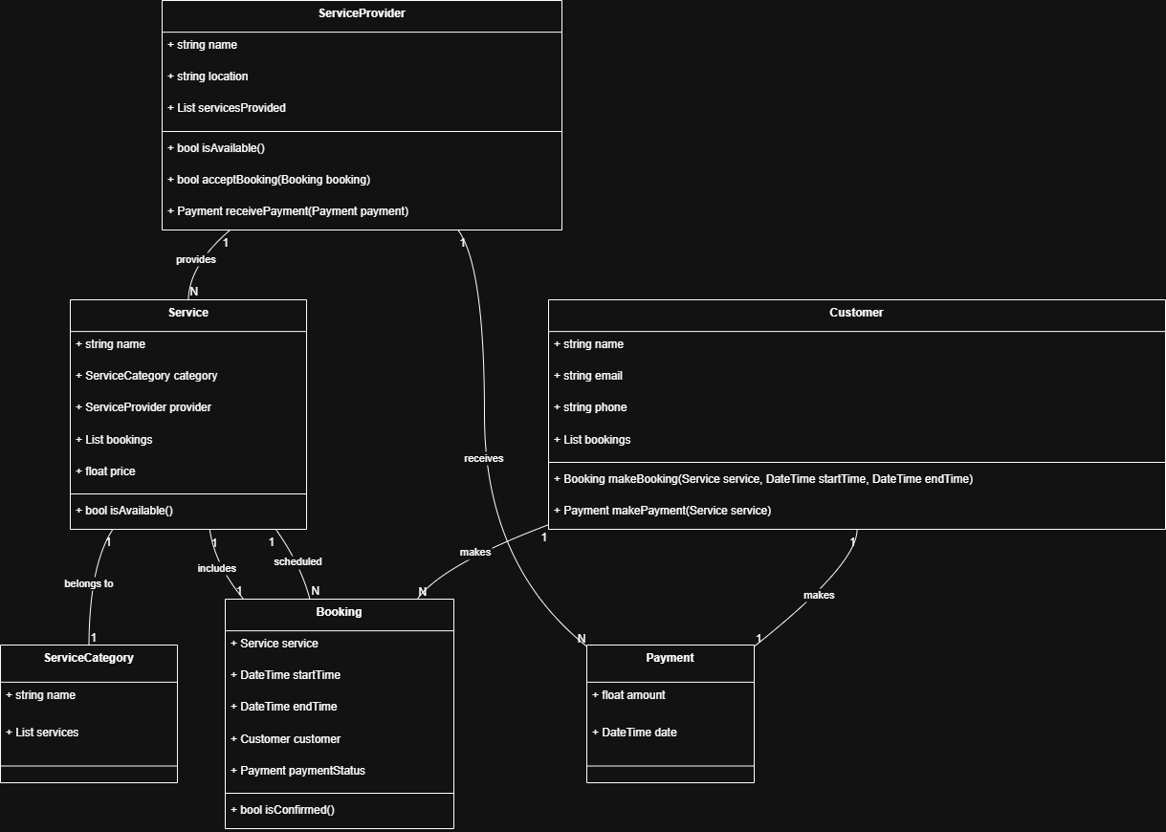

## Interaction Diagram

* + User Login Interaction Diagram

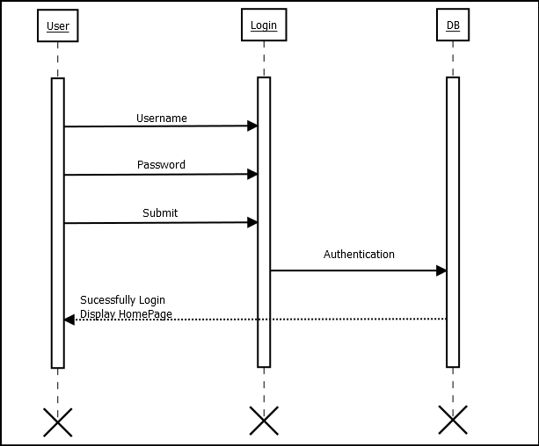

* + Add to cart Interaction Diagram

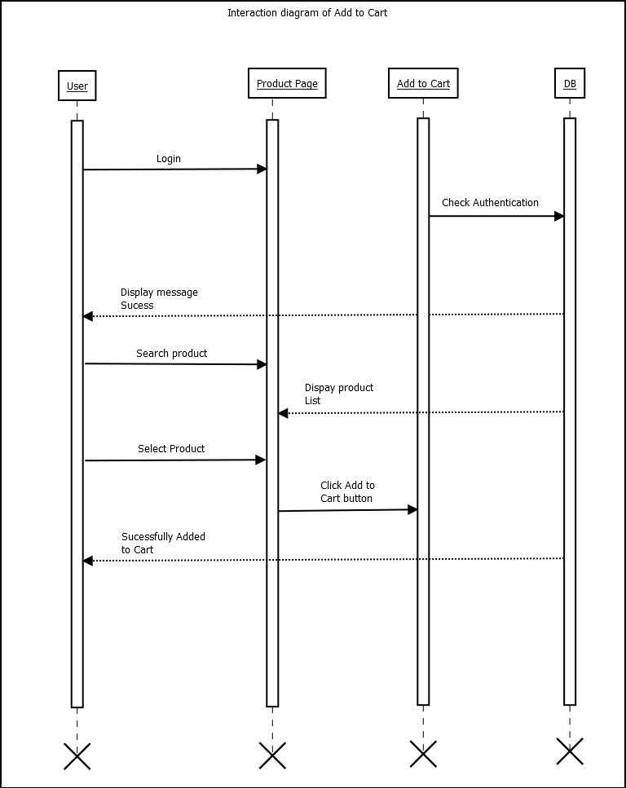

* + Search Interaction Diagram

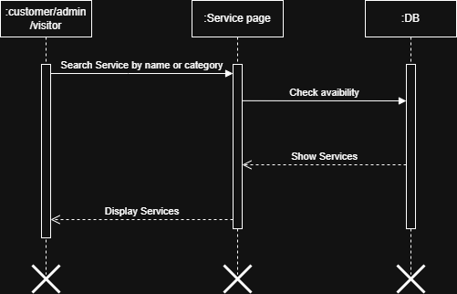

## Activity Diagram

* + Login Activity Diagram

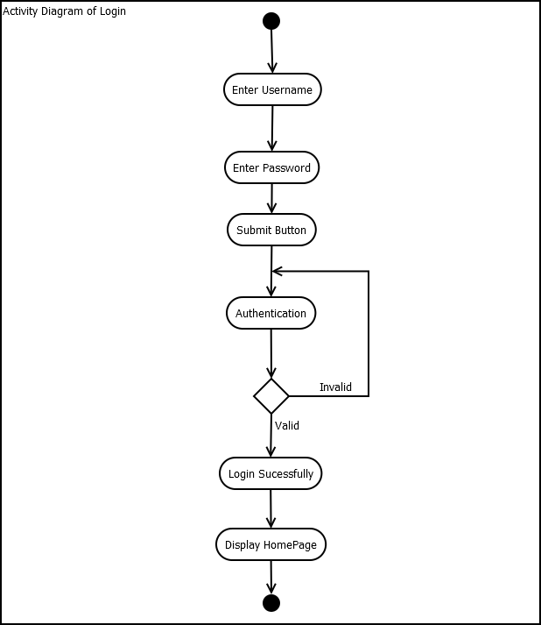

* + Service Booking Activity Diagram

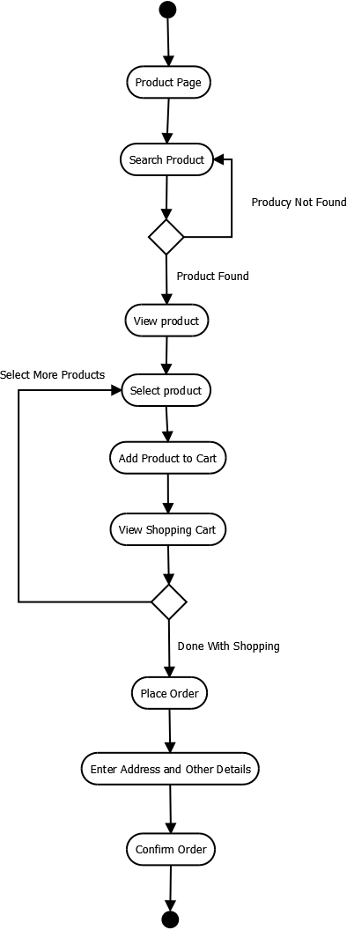

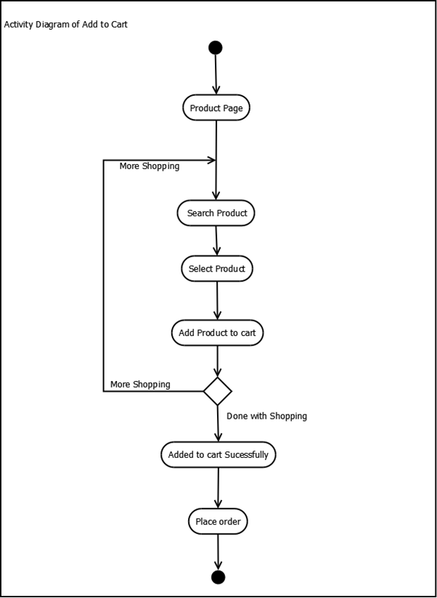

## Data Dictionary

**Table Name:** tbl_user

**Table Description**: contains data about your customers.

|  |  |  |  |  |  |  |  |
| --- | --- | --- | --- | --- | --- | --- | --- |
| Field Name | Data Type (with Size) | Constraint | | Description | | Sample Data | |
| Id | Bigint(20) | **Primary Key** | | Id of the user | | Auto_increment | |
| Name | Varchar(225) | | Not Null | | Name of the user | | Kasim | |
| Image | Varchar(225) | Not Null | | Image of the profile | | profile.jpg | |
|  |  |  | |  | |  | |
| Address | text | Not Null | | Address of the user | | 24, Aakash Tower | |
| Password | Varchar(225) | Not Null | | Password of the account | | Qtgj@12 | |

**Table Name:** tbl_service_category

**Table Description**: contains data about your customers.

|  |  |  |  |  |  |  |  |
| --- | --- | --- | --- | --- | --- | --- | --- |
| Field Name | Data Type (with Size) | Constraint | | Description | | Sample Data | |
| Id | Bigint(20) | **Primary Key** | | Id of the user | | Auto_increment | |
| Name | Varchar(225) | | Not Null | | Name of the category | | salon | |
| Image | ImageField | Not Null | | Image of the profile | | profile.jpg | |

**Table Name:** service_booking

**Table Description**: contains data about service bookings.

|  |  |  |
| --- | --- | --- |
| Column Name | Data Type | Description |
| Booking ID | INT (Primary Key, Auto Increment) | Unique identifier for each booking |
| User ID | INT (Foreign Key) | References the user who booked the service |
| Service ID | INT (Foreign Key) | References the service being booked |
| Provider ID | INT (Foreign Key) | References the service provider |
| Booking Date | DATETIME | Date and time of booking |
| Service Date | DATETIME | Scheduled date and time of service |
| Status | ENUM ('Pending', 'Confirmed', 'Completed', 'Cancelled') | Booking status |
| Payment Status | ENUM ('Pending', 'Paid', 'Refunded') | Payment status |
| Amount | DECIMAL(10,2) | Total service cost |
| Payment Method | VARCHAR(50) | Payment method used (Card, UPI, etc.) |
| Address | TEXT | Service location address |

**Table Name:** service_provider_details

**Table Description**: contains data about service provider details.

|  |  |  |  |  |
| --- | --- | --- | --- | --- |
| Field Name | Data Type (with Size) | Constraint | Description | Sample Data |
| Provider ID | BIGINT(20) | Primary Key, Auto Increment | Unique identifier for each provider | Auto_increment |
| Name | VARCHAR(225) | Not Null | Name of the service provider | John Doe |
| Email | VARCHAR(255) | Unique, Not Null | Email address of provider | [johndoe@email.com](mailto:johndoe@email.com) |
| Phone Number | VARCHAR(20) | Unique, Not Null | Contact number | +1234567890 |
| Address | TEXT | Not Null | Provider's address | 456 Service Lane, City |
| Profile Image | ImageField | Not Null | Image of the provider | provider.jpg |
| Service Type | VARCHAR(255) | Not Null | Type of service offered | Electrician |
| Experience | INT(3) | Not Null | Years of experience | 5 |
| Rating | DECIMAL(3,2) | Default 0.0 | Average provider rating | 4.5 |
| Status | ENUM ('Active', 'Inactive', 'Pending') | Not Null | Current provider status | Active |
| Created At | TIMESTAMP DEFAULT CURRENT_TIMESTAMP | Not Null | Record creation timestamp | 2025-03-08 10:30:00 |
| Updated At | TIMESTAMP DEFAULT CURRENT_TIMESTAMP ON UPDATE  CURRENT_TIMESTAMP | Not Null | Last update timestamp | 2025-03-08 11:00:00 |

**Table Name:** Category

**Table Description**: contains data about service provider details.

|  |  |  |  |  |  |  |  |
| --- | --- | --- | --- | --- | --- | --- | --- |
| Field Name | Data Type (with Size) | Constraint | | | Description | | Sample Data |
| Name | CharField | | Not Null | Name of the user | | Kasim | | |
| Image | ImageField | Not Null | | | Image of the profile | | profile.jpg |
| create_at | DateTimeField | Not Null | | | Create the category | | Created |
| update_at | DateTimeField | Not Null | | | Update the category | | Updated |

**Table Name:** subcatagory

**Table Description**: contains data about service provider details.

|  |  |  |  |  |  |  |  |
| --- | --- | --- | --- | --- | --- | --- | --- |
| Field Name | Data Type (with Size) | Constraint | | | Description | | Sample Data |
| category | VARCHAR(255) | ForeignKey | | | Describe category | | Category1 |
| Name | CharField | | Not Null | Name of the user | | Kasim | | |
| Image | ImageField | Not Null | | | Image of the profile | | profile.jpg |
| create_at | DateTimeField | Not Null | | | Create the category | | Created |
| update_at | DateTimeField | Not Null | | | Update the category | | Updated |

# Development

During the development phase of our urban company website project, we used an agile approach, breaking tasks into smaller ones assigned to team members based on skills and availability. Regular meetings ensured progress tracking and issue resolution. We emphasized balanced workload distribution and frequent code integration to catch conflicts early. Collaboration tools facilitated communication. This process allowed us to maintain steady progress and deliver a high-quality website meeting user needs.

## Coding Standards

PEP 8 Compliance:

All Python code adheres to the PEP 8 style guide to ensure consistent formatting, proper indentation (4 spaces), and a clear code structure.

Django Best Practices:

Project Structure: The project is divided into modular Django apps (e.g., users, services, bookings), promoting separation of concerns.

Models, Views, Templates: Business logic is contained within models and views, while Django’s template language handles the presentation layer.

ORM Utilization: Django’s ORM is used for all database interactions, ensuring safe and efficient data manipulation.

Code Quality and Maintainability:

Modularity: Code is organized into reusable functions, classes, and components to promote DRY (Don't Repeat Yourself) principles.

Documentation: Comprehensive docstrings are added to modules, classes, and functions to explain complex logic and usage.

Testing: Unit and integration tests are written using Django’s testing framework to validate functionality and catch regressions early.

## Screenshots

Login page

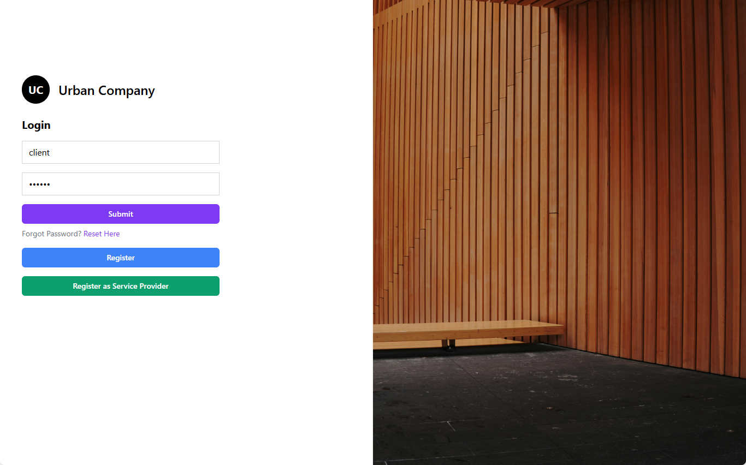

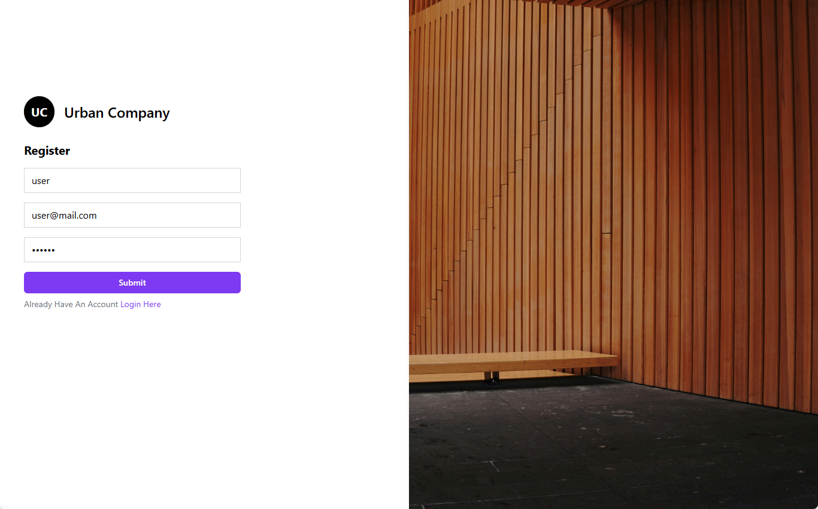

Homepage

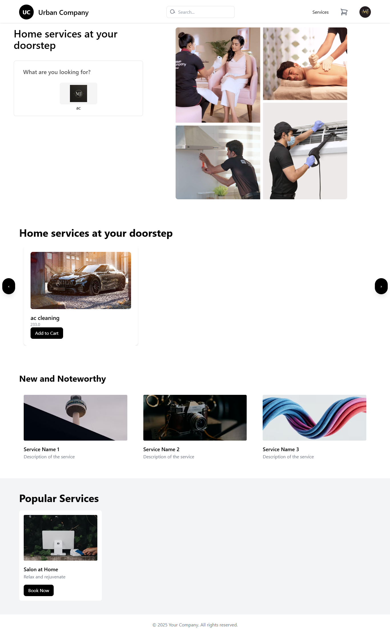

## admin panel

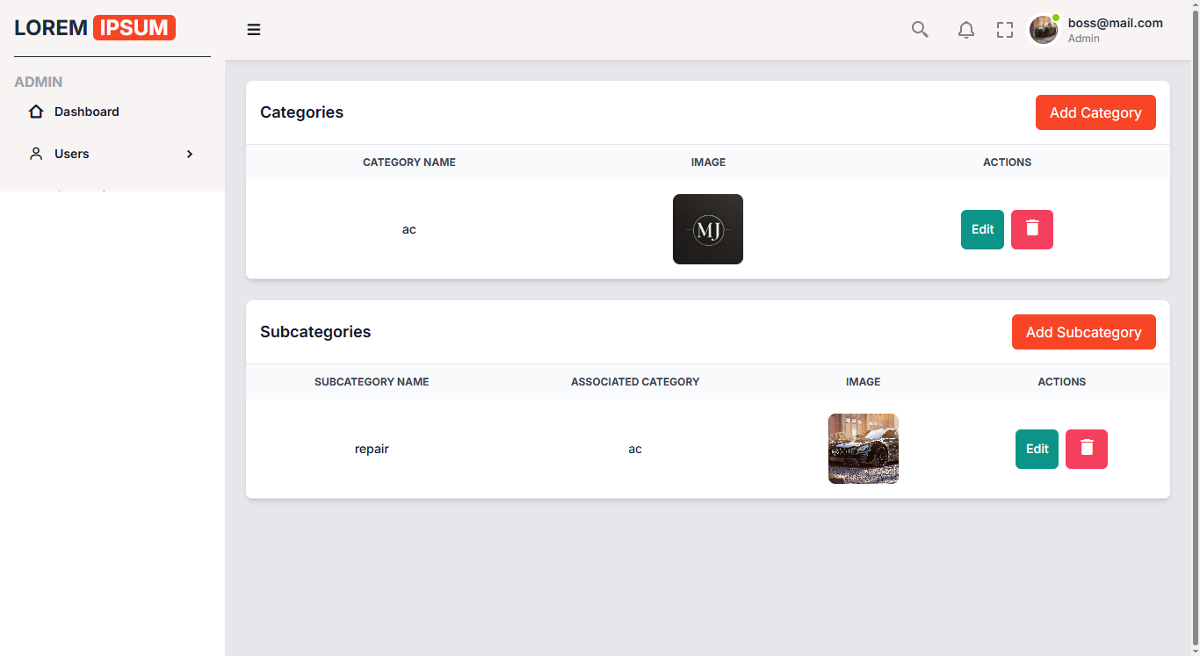

Cart page

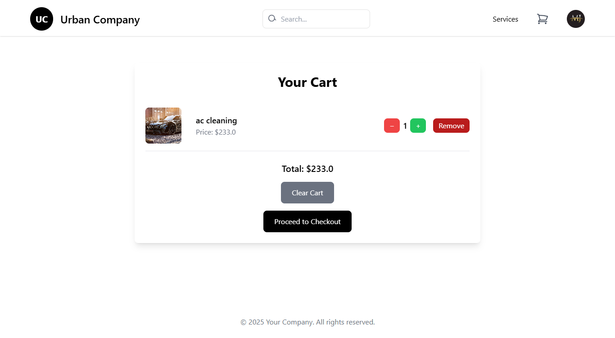

Booking page

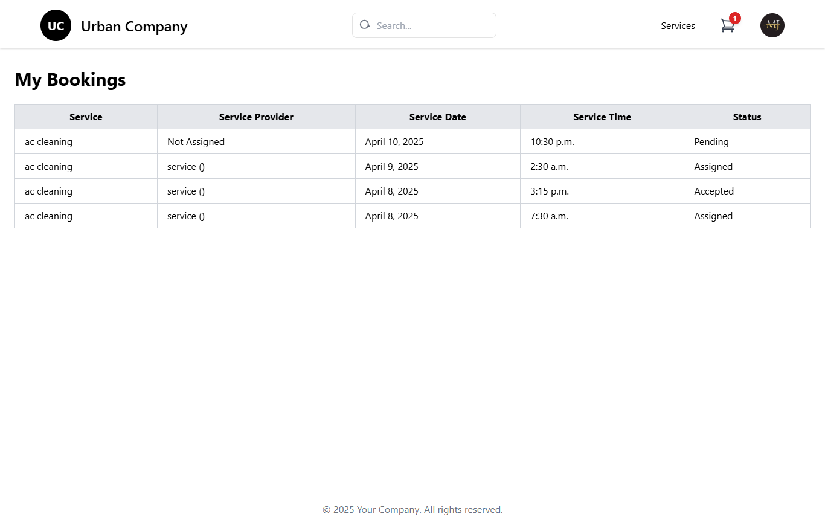

Checkout page

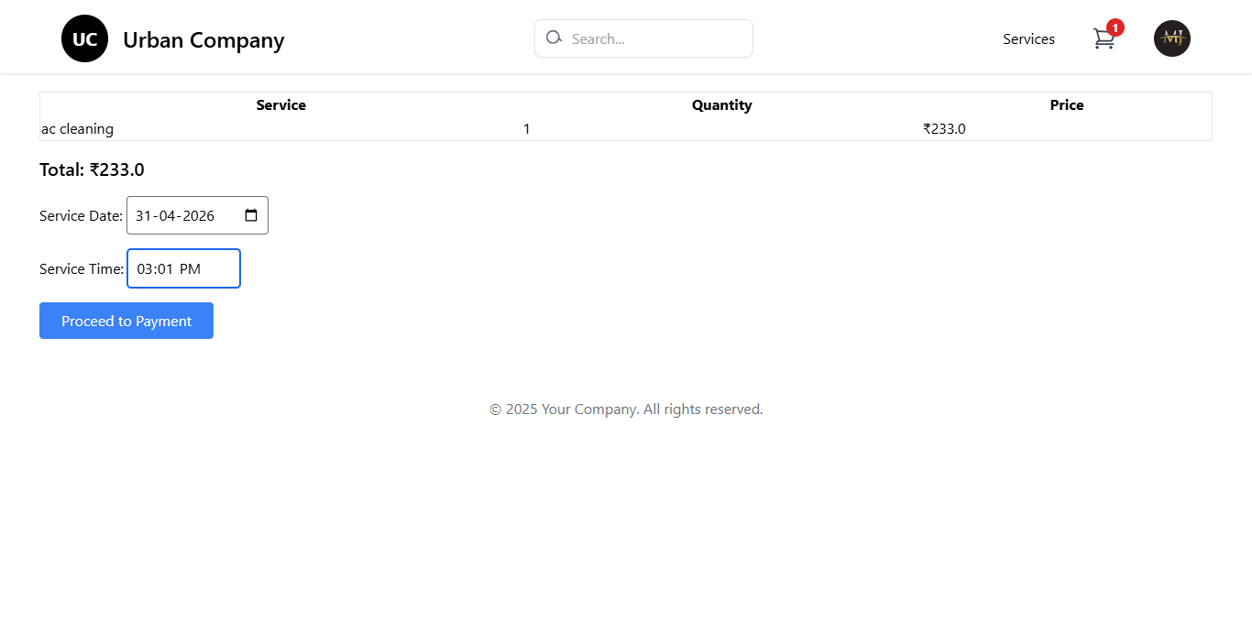

Payment page

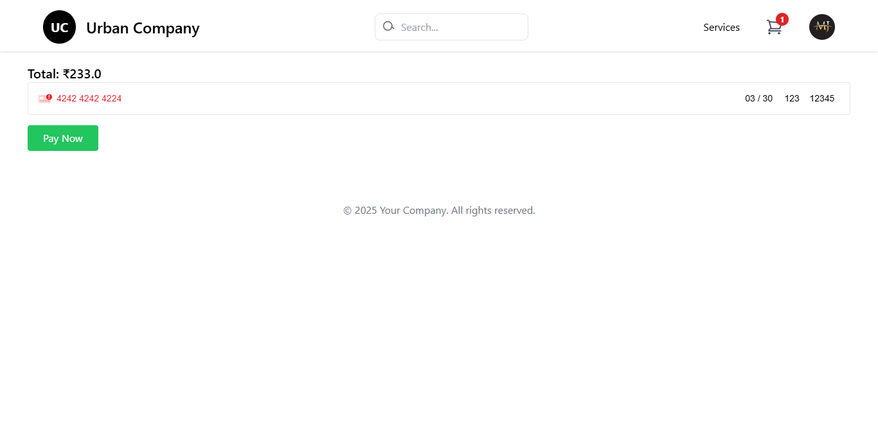

Registration of service provider

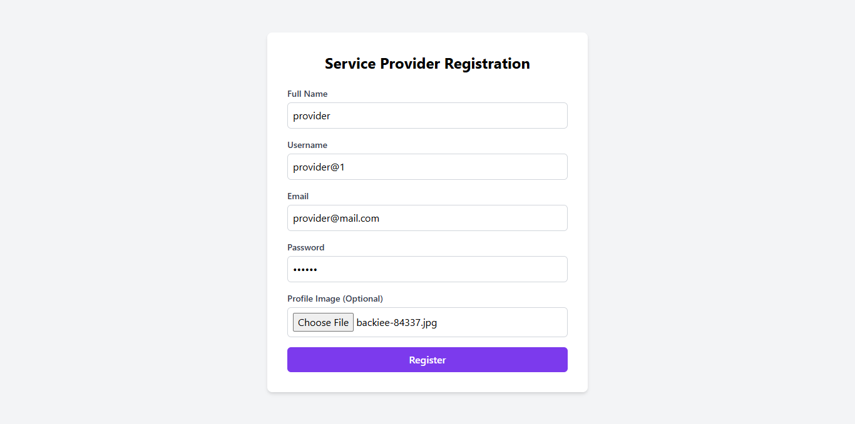

Service provider panel

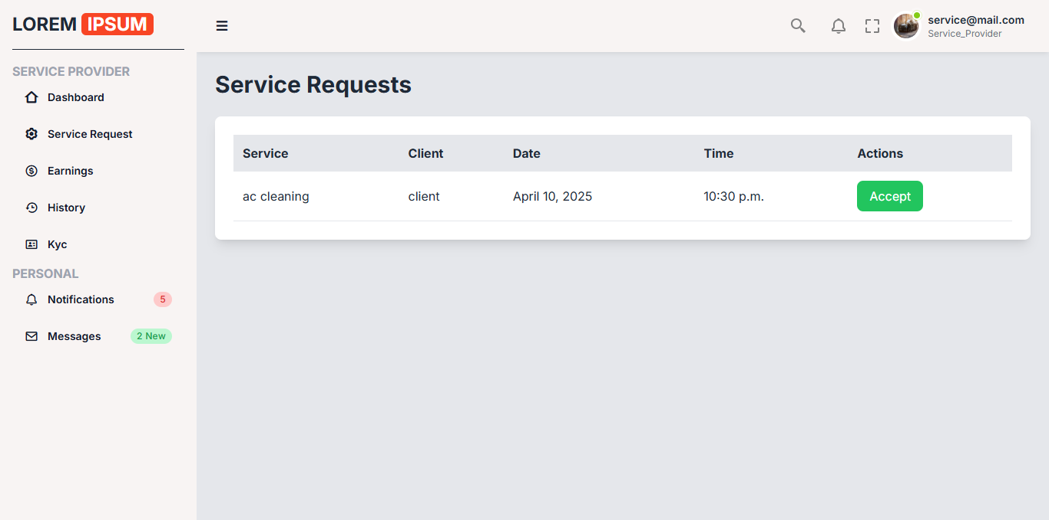

# Agile Documentation

## Agile Project Charter

|  |  |
| --- | --- |
| General Project Information | |
| Project Name | **Urban Clap** |
| Project Champion | **Mu.Jawwad, Tariq, Faiz , Muhammed** |
| Project Sponsor | None |
| Project Manager | None |
| Stakeholders | None |
| Expected Start Date | **19th Jan 2025** |
| Expected Completion Date | **10th April 2025** |

|  |  |
| --- | --- |
| Project Details | |
| Mission | Urban Clap mission is to empower skilled professionals, connect customers with reliable service providers, and deliver seamless, quality home services that enhance everyday living. |
| Vision | Urban Company's vision is to transform the home services landscape into a trusted, innovative platform that elevates both customer experiences and professional growth**.** |
| Scope | Urban Company’s scope spans across diverse home services, including maintenance, repairs, cleaning, beauty, and wellness, enabling seamless connections between trusted professionals and customers nationwide. |

## 

## Agile Road Map

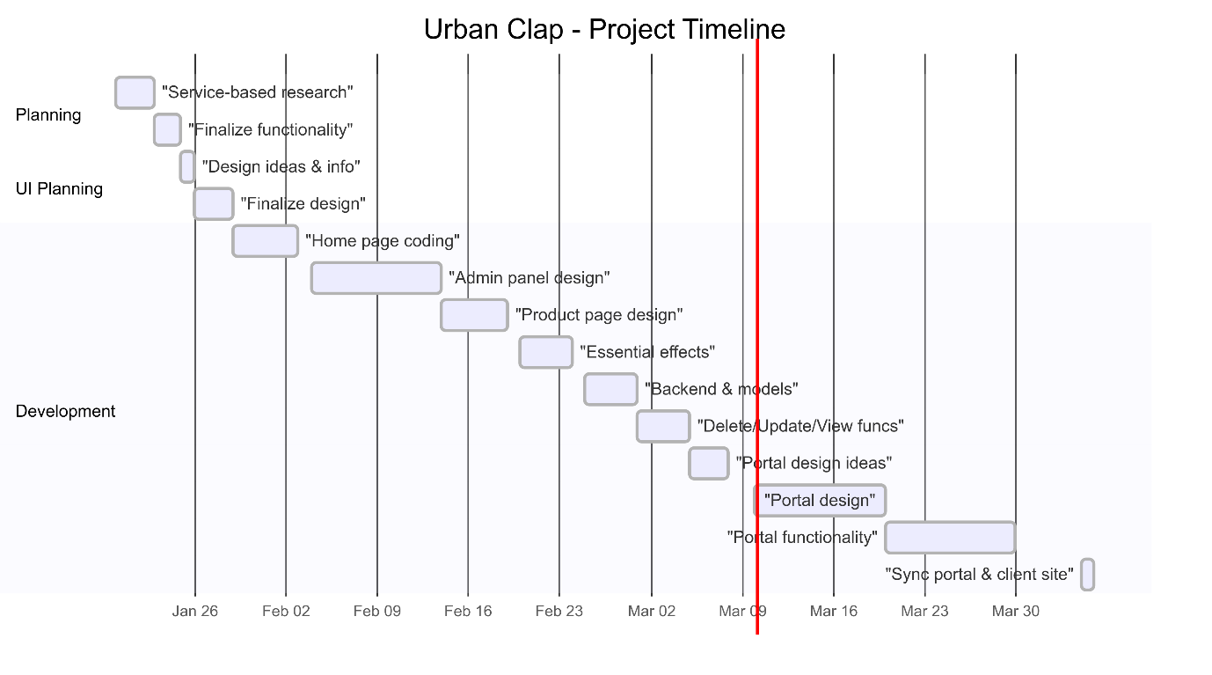

## Agile Project Plan

|  |  |  |  |  |
| --- | --- | --- | --- | --- |
| Task Name | Duration | Start | Finish | Status |
| figuring out how service-based company works | 3d | 20-01-2025 | 22-01-2025 | Complete |
| finalizing functionality for website building | 2d | 23-01-2025 | 24-01-2025 | Complete |
| gathering design ideas and info | 1d | 25-01-2025 | 26-01-2025 | Complete |
| finalizing the design | 3d | 26-01-2025 | 28-02-2025 | Complete |
| website home page coding | 5d | 29-01-2025 | 03-02-2025 | Complete |
| designing the admin panel | 10d | 04-02-2025 | 13-02-2025 | Complete |
| single product page designing | 5d | 14-02-2025 | 19-02-2025 | Complete |
| designing essential effects | 4d | 20-02-2025 | 24-02-2025 | Complete |
| backend create functionality and models | 4d | 25-02-2025 | 01-03-2025 | Complete |
| delete, update and view functionality | 4d | 01-03-2025 | 05-03-2025 | Complete |
| getting design idea for service provider portal | 3d | 05-03-2025 | 10-03-2025 | Complete |
| starting designing of portal | 10d | 10-03-2025 | 20-03-2025 | Under Construction |
| creating functionality for portal and models | 10d | 20-03-2025 | 04-04-2025 | Under Construction |
| synchronizing the portal to client website | 4d | 04-04-2025 | 10-04-2025 | Under Construction |

## Agile User Story ( Minimum 3 Tasks)

|  |  |  |  |
| --- | --- | --- | --- |
| User Story ID | As s(type of user) | I want to perform | So that I can(achieve some task) |
| 1 | Admin | Login | Access My Account |
| 2 | Admin | Manage Services | CRUD Operation on services |
| 3 | visitor | exploring categories | explore more categories |
| 4 | User | Book Services | Book Various Types of Services |
| 5 | Visitor | Search Services | Browse Services |
| 6 | User | Give feedback | How to improve |
| 7 | User | See History | Access Past Booked Service History |
| 8 | Visitor | Add to cart | Can Add the service to cart |
| 9 | Admin | Validate Provider | Can verify the Provider Details |

## Agile Release Plan

|  |  |  |  |  |  |
| --- | --- | --- | --- | --- | --- |
| Task Name | Duration | Start | Finish | Status | Release Date |
| figuring out how service-based company works | 3d | 20-01-2025 | 22-01-2025 | Complete | 22-01-2025 |
| finalizing functionality for website building | 2d | 23-01-2025 | 24-01-2025 | Complete | 24-01-2025 |
| gathering design ideas and info | 1d | 25-01-2025 | 26-01-2025 | Complete | 26-01-2025 |
| finalizing the design | 3d | 26-01-2025 | 28-02-2025 | Complete | 28-02-2025 |
| website home page coding | 5d | 29-01-2025 | 03-02-2025 | Complete | 03-02-2025 |
| designing the admin panel | 10d | 04-02-2025 | 13-02-2025 | Complete | 13-02-2025 |
| single product page designing | 5d | 14-02-2025 | 19-02-2025 | Complete | 19-02-2025 |
| designing essential effects | 4d | 20-02-2025 | 24-02-2025 | Complete | 24-02-2025 |
| backend create functionality and models | 4d | 25-02-2025 | 01-03-2025 | Complete | 01-03-2025 |
| delete, update and view functionality | 4d | 01-03-2025 | 05-03-2025 | Complete | 05-03-2025 |
| getting design idea for service provider portal | 3d | 05-03-2025 | 10-03-2025 | Complete | 10-03-2025 |
| starting designing of portal | 10d | 10-03-2025 | 20-03-2025 | Under Construction | 20-03-2025 |
| creating functionality for portal and models | 10d | 20-03-2025 | 04-04-2025 | Under Construction | 04-04-2025 |
| synchronizing the portal to client website | 4d | 04-04-2025 | 10-04-2025 | Under Construction | 10-04-2025 |

## Agile Sprint Backlog

|  |  |  |  |  |  |
| --- | --- | --- | --- | --- | --- |
| Task Name | Story | Sprint Ready | Priority | Status | Story Point |
| Sprint#1: Basic Project Structure | Yes | Yes | High | Complete | 10 |
| UI Designing | Yes | Yes | High | Complete | 10 |
| Database Management | Yes | Yes | High | Complete | 10 |
| Sprint#2: Login | Yes | Yes | High | Complete | 10 |
| UI Designing | Yes | Yes | High | Complete | 8 |
| Email and Password verification | Yes | Yes | High | Complete | 8 |
| View and select Service | Yes | Yes | Medium | Complete | 8 |
| Place Order | Yes | Yes | High | Complete | 9 |
| Make payment | Yes | Yes | High | Complete | 2 |
| Give Feedback | Yes | Yes | Low | Complete | 4 |
| Sprint#3: Manage Service Provider (Admin) | Yes | Yes | Medium | Complete | 4 |
| View Provider Details | Yes | Yes | High | Complete | 8 |
| Verify The Provider Details | Yes | Yes | High | Complete | 8 |
| Approve/Disapprove Provider Details | Yes | Yes | Medium | Complete | 6 |
| Sprint#4: Manage Order (Admin) | Yes | Yes | Medium | Complete | 6 |
| View Order Details | Yes | Yes | High | Complete | 10 |
| Update Order Details | Yes | Yes | High | Complete | 10 |
| Delete Order Details | Yes | Yes | High | Complete | 8 |
| Sprint#5: Manage Order status (Admin) | Yes | Yes | High | Complete | 8 |
| Update Order status | Yes | Yes | Low | Complete | 4 |
| Sprint#6: Manage Feedback (Admin) | Yes | Yes | Low | Complete | 2 |
| View Feedback | Yes | Yes | Medium | Complete | 4 |
| Delete Feedback | Yes | Yes | Medium | Complete | 4 |
| Sprint#7: Manage Services (Admin) | Yes | Yes | Medium | Complete | 4 |
| View Services | Yes | Yes | Medium | Complete | 4 |
| Add Services | Yes | Yes | Medium | Complete | 4 |
| Edit Services | Yes | Yes | Medium | Complete | 4 |
| Delete Services | Yes | Yes | High | Complete | 10 |
| Sprint#8: Manage Profile(Admin) | Yes | Yes | High | Complete | 8 |
| View Profile | Yes | Yes | High | Complete | 8 |
| Add Profile | Yes | Yes | High | Complete | 8 |
| Update Profile | Yes | Yes | High | Complete | 8 |
| Delete Profile | Yes | Yes | High | Complete | 8 |
| Sprint#9: Manage Category (Admin) | Yes | Yes | High | Complete | 8 |
| View Category | Yes | Yes | High | Complete | 8 |
| Add Category | Yes | Yes | High | Complete | 8 |
| Update Category | Yes | Yes | High | Complete | 8 |
| Delete Category | Yes | Yes | High | Complete | 8 |
| Sprint#10 See leads (Provider) | Yes | Yes | High | Complete | 8 |
| View Nearby Service Requests | Yes | Yes | High | Complete | 8 |
| Accept/Decline Lead Request | Yes | Yes | High | Complete | 8 |
| See Past work History | Yes | Yes | High | Complete | 8 |

## Agile Test Plan

|  |  |  |  |  |  |  |  |  |
| --- | --- | --- | --- | --- | --- | --- | --- | --- |
| Project Name | | Urbanclap | | | Device | | DELL intel core i5 | |
| 7th gen | |  | | |  | |  | | |
| Test Case Id | | 1 | | | Test Title | | Login | | |
| Module Name | | Login | | | Tested By | | Mu.Jawwad | | |
| Priority | High | | Execution Date | 6/02/2025 | | Actual Result | | Pass | | |
| Test | Test Step | | Action | Expected Result | | Account has opened | | Yes | | |
| 1 | Enter Email and Password | | Login | Homepage should open | | Invalid Account holder name | | No | | |
| 2 | Enter invalid email | |  |  | | Invalid Account holder ID | | No | | |
|  | User must put right email credentials | | Must give message for not putting right credentials | Give the message for not putting proper email | | Valid Account holder ID | | Yes | | |

|  |  |  |  |  |  |  |  |  |
| --- | --- | --- | --- | --- | --- | --- | --- | --- |
| Project Name | | Urbanclap | | | Device | | DELL intel core i5  7th gen | |
| Test Case Id | | 2 | | | Test Title | | Add to cart | |
| Module Name | | Add Service | | | Tested By | | Mu.Jawwad | |
| Priority | | High | | | Execution Date | | 05/03/2025 | |
| Test | Test Step | | Action | Expected Result | | Actual Result | | Pass |
| 1 | Service add | | Admin Account Request check login or not | Login page redirection | | Login page redirection and check credential | | Yes |
| 2 | Create  New Service | | New Service Creation Process | Successfully Creation of Service | | Successful creation without error | | Yes |
| 3 | Update  the Service | | Service update process | It should update the data to the relevant id | | Update successful with respectful id | | Yes |
| 4 | Deletion of the service | | Deletion of service | It should delete the Service relevant to id | | Deletion Successful with respectful id | | Yes |
| 5 | Crud  on Category | | Crud operation should work on Category | Crud operation should work on Category | | Successful | | Yes |

## Earned-value and burn charts

# **Proposed Enhancements**

For proposed enhancements to our Urban clap website, we aim to implement several key features to enhance user experience and expand our business capabilities. Firstly, we plan to integrate personalized Service recommendations based on user preferences and browsing history to increase engagement and conversion rates. Additionally, implementing a customer loyalty program with rewards and incentives will encourage repeat purchases and foster customer loyalty. We also intend to enhance our Service catalog by adding more diverse and unique gift items to cater to a wider audience. Moreover, integrating social media sharing options and user-generated content features will help increase brand visibility and drive organic traffic to our website. Furthermore, implementing advanced analytics and reporting tools will provide valuable insights into customer behavior and help optimize marketing strategies and product offerings. Lastly, we plan to invest in mobile app development to provide a seamless Service booking experience across different devices and improve accessibility for our customers. These proposed enhancements align with our goal of continually improving our Urban clap platform to better serve our customers and stay competitive in the market.

# **Conclusion**

In conclusion, these proposed enhancements will significantly elevate the user experience, drive customer engagement, and expand our business potential. By integrating personalized recommendations, a customer loyalty program, a diverse service catalog, and social media sharing features, we aim to attract and retain more users while increasing brand visibility. Additionally, leveraging advanced analytics will enable data-driven decision-making to refine our marketing and service offerings. Lastly, investing in mobile app development will ensure a seamless and accessible booking experience. These strategic improvements will strengthen our UrbanClap platform, keeping us competitive and aligned with evolving customer needs.

# **Bibliography**

|  |  |  |
| --- | --- | --- |
| Task Name | Software used | References |
| Django/Tailwind Coding  (New Tasks) | Visual Studio | Ip.pwskills.com, W3school.com, GeeksforGeeks, TOPS Technologies, Tutorialspoint.com , YouTube,Chatgpt |
| Timeline Chart | Mermaid | Chatgpt |
| Diagrams | Draw.io | Chatgpt,deepseek, |
| Agile Road Map | MS Excel, Smart Sheet | - |
| Burn Chart | MS Excel | - |